|  |  |
| --- | --- |
| **HOA LAC** | **COMPUTER FUNDAMENTAL DEPARTMENT** |

**PRACTICAL EXAM**

BLOCK 1 – SPRING 2018

**Paper No: 12**

14/03/2018

##### SUBJECT: Database System (DBI202)

**Duration: 85 minutes**

BD14997_

**Student Information**

|  |  |  |  |
| --- | --- | --- | --- |
| Name: |  | Roll number: |  |
| Room No: |  | Class: |  |

BD14997_

**For STAFF only**

|  |  |
| --- | --- |
| **mark** | **marked by**  **(name and signature)** |

**Signature of Proctor**

BD14997_**INSTRUCTIONS**

**Please read the instructions carefully before doing the questions.**

* You can use materials in your computer, notebook and text book.
* While doing the PE exam, you **must disconnect your computer from a network**.
* You are **NOT allowed** to use any device to share data with others.

Beside the above conditions, students must follow the following requirements**:**

1. Down load the compressed file in the **\\fstu\Khao\_Thi\03\_Exam\_Online\PRJ311\_for students.zip** to your computer and decompress it.
2. **THIS PART IS VERY IMPORTANT, PLEASE READ IT CAREFULLY AND FOLLOW THE INSTRUCTIONS.**

* BEFORE starting doing anything. Open your SQL Server creates a database named DBI202\_SPRING18\_SAMPLE\_TEST
* Create a folder named **RollNo\_Name\_DBI202\_PaperNo** (1) **,** e.g.se01245\_LongNT\_DBI202\_01.

All files created are located under above folder.

* For each question asks to write a database script. Create a file with the name corresponding to the index of the question. For example, **for question 1, part a**, we will create a file named **1\_a.sql**, **for question 3**, we will create a file named **3.sql**. This file contains only the required workflow commands that do not include other commands including the database context switch (**not including use [database name]**).
* The questions do not require writing a database script, use the pen to fill in the test paper.

One of the above conditions is not met, your work is considered unsatisfactory in this section

1. On completion, compress the whole folder (1) with the same name in ZIP or RAR format and copy the compressed file to:

**\\fstu\Khao\_Thi\04\_Nop\_Bai\_Thi\PRJ311\_15.10\ROOM <Your room>**

Ex: you’re in Room 510 => copy your compressed file to

[**\\fstu\Khao\_Thi\04\_Nop\_bai\_thi\PRJ311\_15.10\ROOM**](file:///\\fstu\Khao_Thi\04_Nop_bai_thi\CSD201_13.11\ROOM) **510**

1. **Write your name and your roll number and hand in exam papers.**

**If at least one of the above requirements is not followed, the exam will get ZERO.**

**QUESTIONS**

**1.Select all male student**

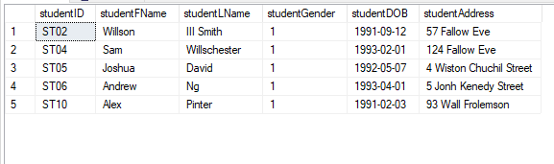

select \* from student

where studentgender = 1

**2. Select all student with average score of each student**

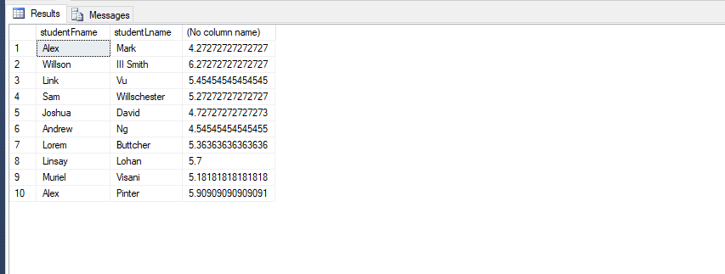

select s.studentFName, s.studentLName, avg(e.examscore)

from exam e join student s

on e.studentid = s.studentid

group by s.studentFName, s.studentLName, e.studentid

**3. Select all student who have average score between 5 and 6**

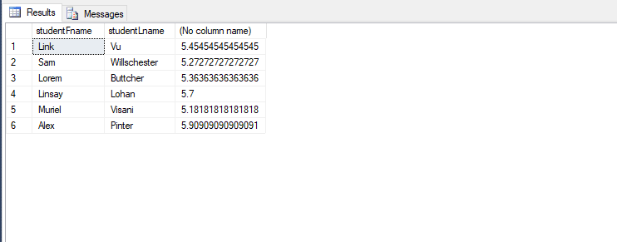

select s.studentFName, s.studentLName, avg(e.examscore)

from exam e join student s

on e.studentid = s.studentid

group by s.studentFName, s.studentLName, e.studentid

having avg(e.examscore) between 5 and 6

**4. Count all student in each class**

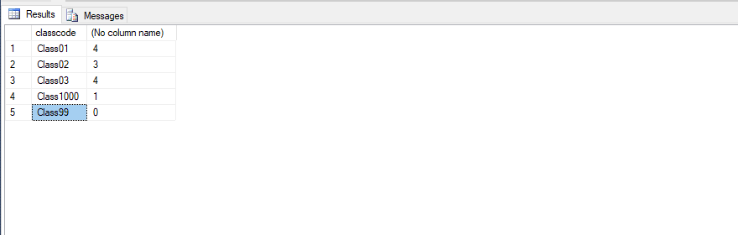

select c.classcode, count(studentid)

from student\_class sc right join class c

on sc.classCode = c.classCode

group by c.classcode

**5. List all male students who are elder than 20.**

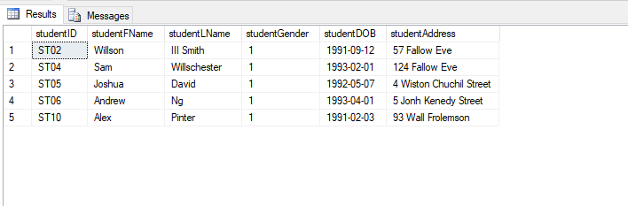

select \* from student

where (year(getdate()) - year(studentdob)) > 20

and studentgender = 1

**6. List all students and their class name.**

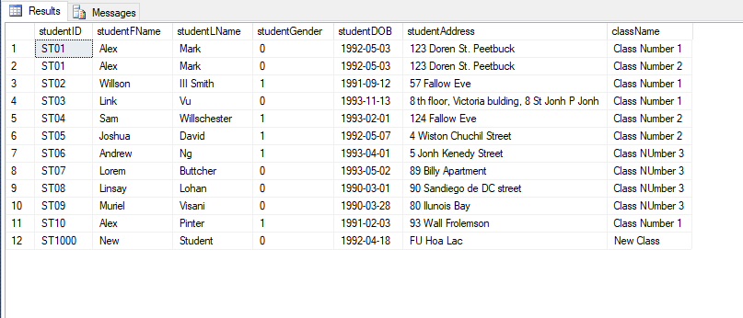

select s.\* , c.classname

from student s join student\_class sc

on s.studentid = sc.studentid join class c

on sc.classCode = c.classCode

**7. List all students who win highest scholarship.**

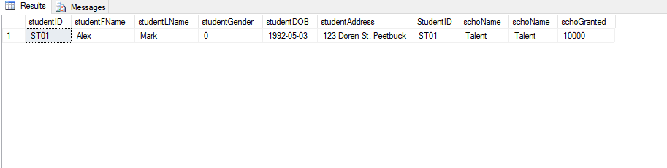

select st.\*,s.\*

from student\_scholarship ss join scholarship s

on ss.schoname = s.schoname join student st

on ss.studentid = st.studentid

where s.schoGranted =

(select max(s.schogranted) as maxScho

from student\_scholarship ss join scholarship s

on ss.schoname = s.schoname)

**8. List the total budget to grant for each types of scholarships.**

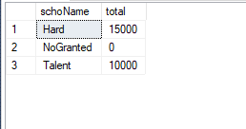

with rs as(select s.schoname,s.schogranted, count(ss.schoname) as number

from Scholarship s left join Student\_Scholarship ss

on s.schoName = ss.schoname

group by s.schoname,s.schogranted, ss.schoname)

select rs.schoname, (rs.schogranted \* rs.number) as total

from rs

**Solution**

**1.**

select \* from student

where studentgender = 1

**2.**

select s.studentFname, s.studentLname, avg(e.examscore)

from exam e join student s

on e.studentid = s.studentid

group by s.studentFname,s.studentLname, e.studentID

**3.**

select s.studentFname, s.studentLname, avg(e.examscore)

from exam e join student s

on e.studentid = s.studentid

group by s.studentFname,s.studentLname, e.studentID

having avg(e.examscore) between 5 and 6

**4.**

select c.classcode, count(sc.classcode)

from student\_class sc right join class c

on sc.classcode = c.classcode

group by c.classCode, sc.classcode

**5.**

select \* from student

where (year(getdate()) - year(studentDOB)) > 20

**6.**

select s.\*, c.className

from student s join Student\_Class sc

on s.studentID = sc.studentID

join Class c on sc.classCode = c.classCode

**7.**

select \* from Student s join Student\_Scholarship sc

on s.studentID = sc.StudentID join Scholarship c

on sc.schoName = c.schoName

where c.schoGranted = (

select max(c.schogranted)

from Student\_Scholarship sc join Scholarship c

on sc.schoName = c.schoName)

**8.**

with rs as

(select s.schoName, s.schoGranted, count(sc.StudentID) as number

from Student\_Scholarship sc right join

Scholarship s on sc.schoName = s.schoName

group by s.schoGranted, s.schoName)

select rs.schoName, rs.schogranted \* rs.number as total from rs